CHAROTAR UNIVERSITY OF SCIENCE AND TECHNOLOGY

DEVANG PATEL INSTITUTE OF ADVANCE TECHNOLOGY & RESEARCH

Department of Information Technology
Subject Name: Data Engineering
Semester: 5th
Subject Code: ITUC301
Academic Year: 2026-27 (ODD)

PRACTICAL CIE - FILE

PRACTICAL – CIE-1

Problem Definition
An e-commerce organization collects data from multiple sources, including customer and product information in CSV format, transaction data in JSON format, and web application user activity logs generated continuously.
The objective is to design and implement a simplified end-to-end data engineering pipeline using Python and local files.

1. DATA ENGINEERING LIFECYCLE

Objective
To design and demonstrate the basic data engineering lifecycle for the given e-commerce system.

Pipeline
Data Generation → Data Ingestion → Storage → Transformation → Data Serving
Folder Structure
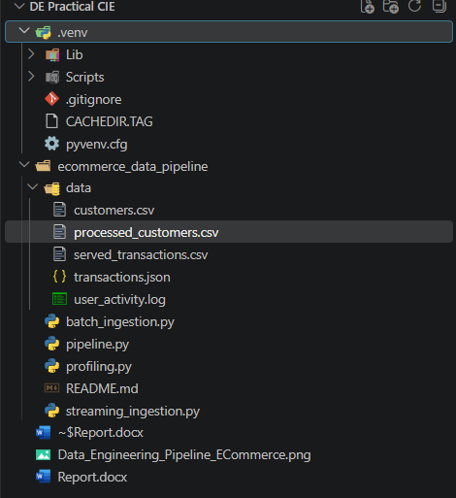

Pipeline Diagram:
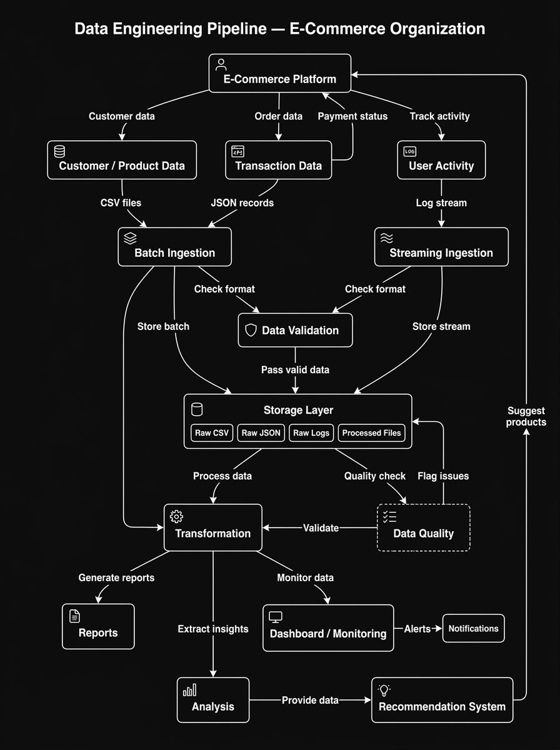
Figure 1: Data Engineering Lifecycle

Data Quality Consideration
Data quality should be checked during the pipeline to identify missing values, duplicate records, and inconsistent data formats before the data is used for analysis.

2. DATA GENERATION AND PROFILING

Objective
To create sample data from multiple sources and identify basic data quality issues.

Data Sources

1. Customer/Product Data
File: customers.csv
Fields:
customer_id, name, email, product, price

2. Transaction Data
File: transactions.json
Fields:
transaction_id, customer_id, amount, timestamp

3. User Activity Data
File: user_activity.log
Format:
timestamp, customer_id, event
These three sources represent CSV, JSON/API, and continuously generated log data.

Data Quality Issues
The sample data contains the following issues:
- Missing/null values
- Duplicate records
- Inconsistent timestamp formats

Profiling
The Python profiling program performs:
- Reads CSV data.
- Reads JSON data.
- Reads log data.
- Displays records.
- Checks missing values.
- Checks duplicate records.
- Displays data types.
- Checks timestamp formats.

Observed Issues
- Missing email value
- Duplicate customer record
- Missing transaction amount
- Duplicate transaction record
- Inconsistent timestamp format
Figure 2: Data Profiling Output
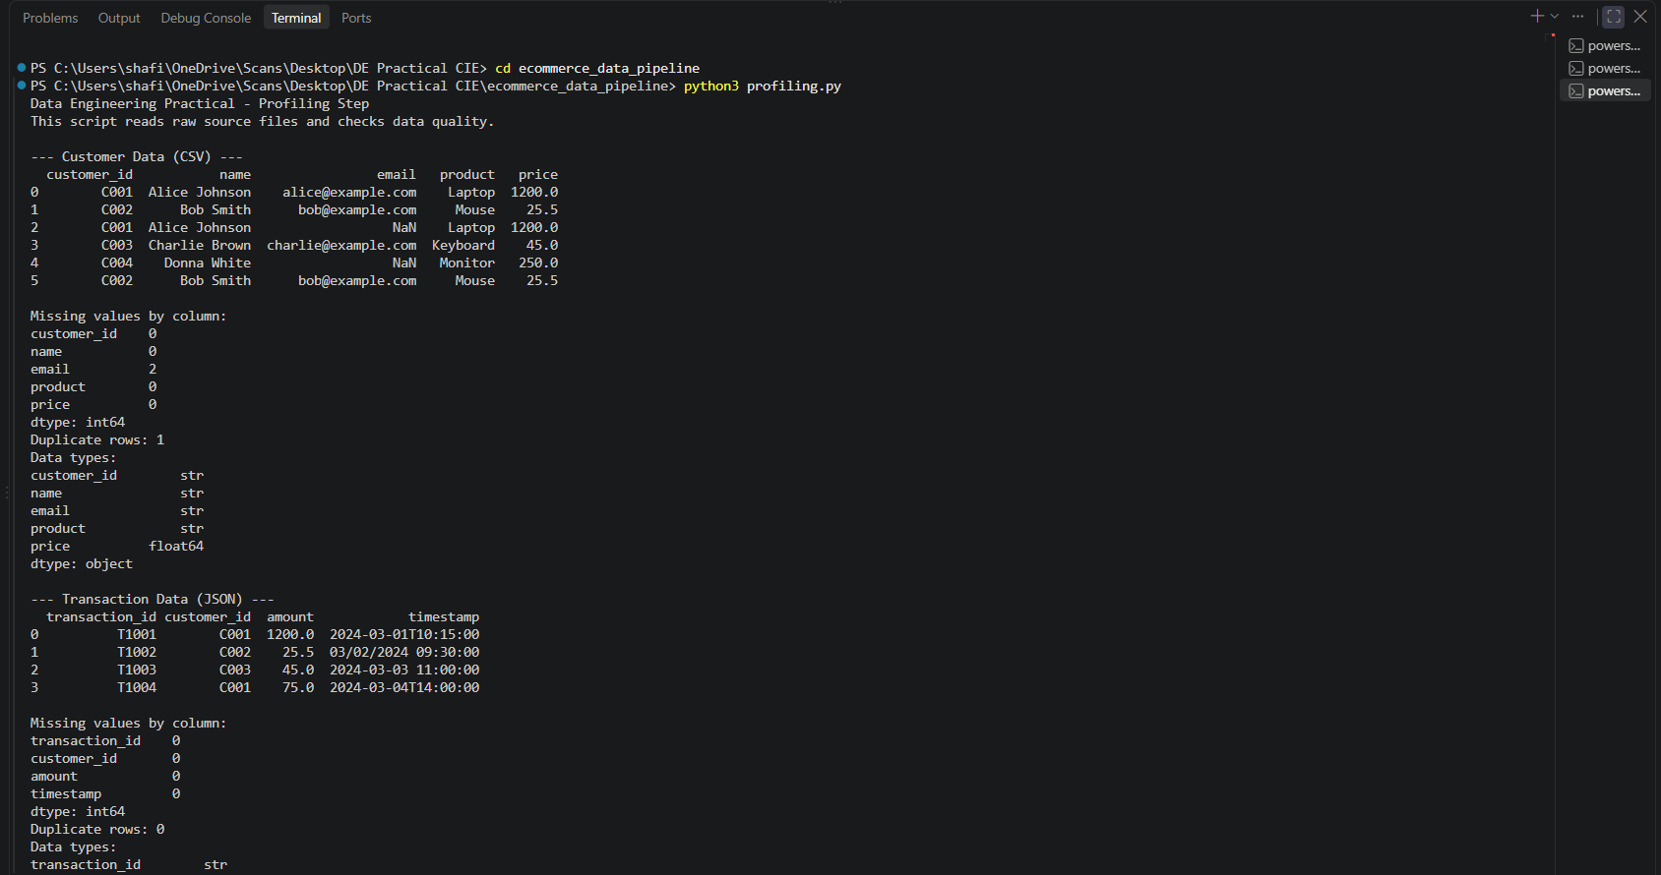
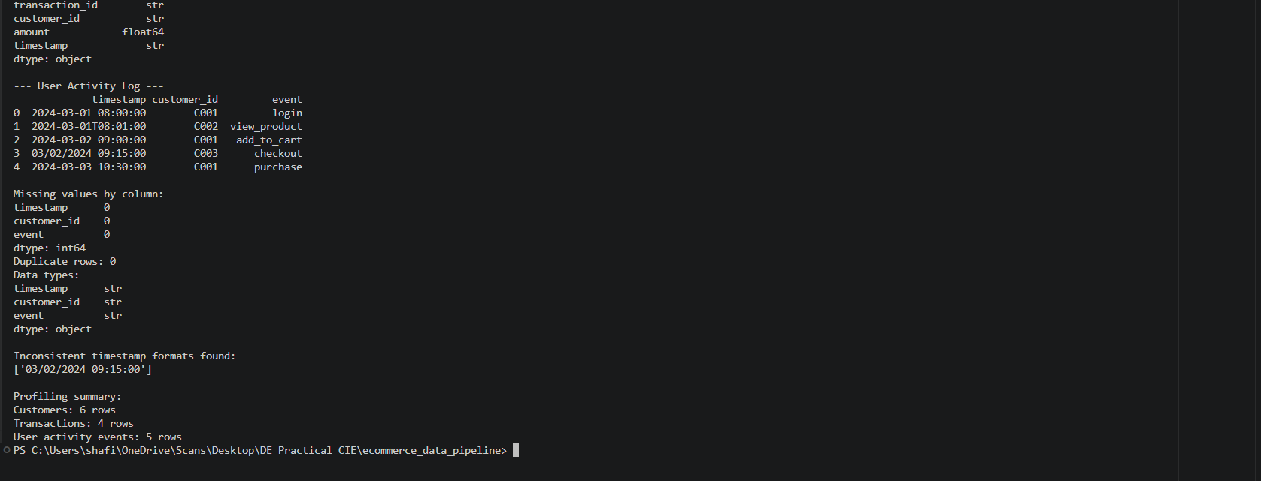

3. BATCH AND STREAMING INGESTION

Objective
To implement and compare batch ingestion and streaming-style ingestion using Python.

A. Batch Ingestion
Batch ingestion processes a group of records together.
In this practical, customers.csv is used as the batch data source.

Process
customers.csv → Read Data → Remove Duplicates → Handle Missing Values → Save Processed Data
The processed data is stored as: data/processed_customers.csv

Steps
- Read the CSV file.
- Display raw records.
- Remove duplicate records.
- Handle missing email values.
- Save cleaned data.
- Display processed records.
Figure 3: Batch Ingestion Output
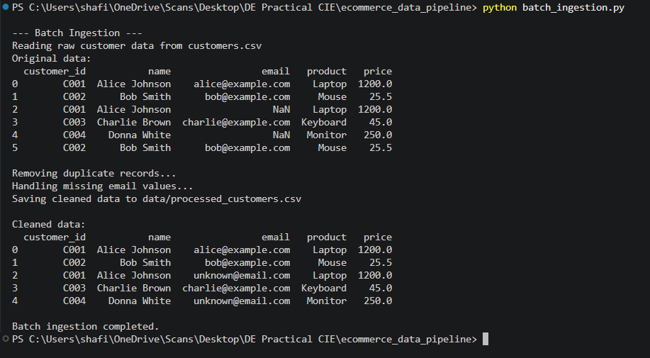
Figure 4: Processed Customer Data
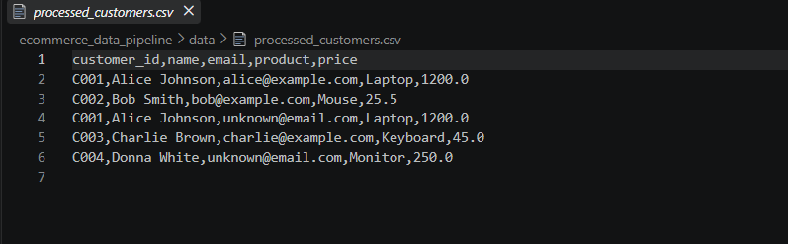

B. Streaming-Style Ingestion
Streaming ingestion processes incoming events individually.
In this practical, user_activity.log is used to simulate continuous web activity.

Process
User Activity Log → Read Event → Process Event → Read Next Event → Process Event
The program uses time.sleep(1) to simulate continuous event arrival.

Steps
- Read the log file.
- Read one event at a time.
- Display the incoming event.
- Process the event.
- Wait for a short interval.
- Process the next event.
Figure 5: Streaming-Style Ingestion Output

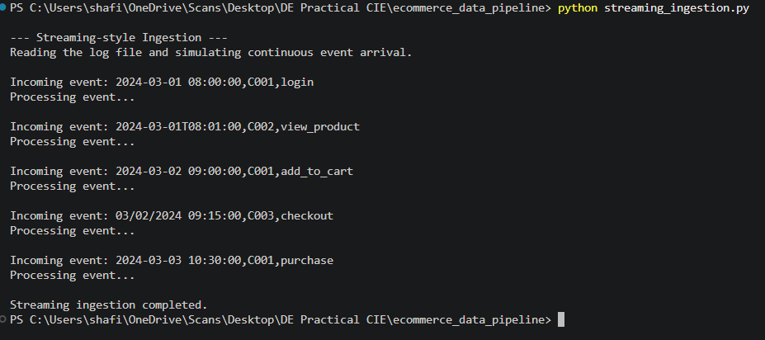

Batch vs Streaming Comparison
Parameter | Batch Ingestion | Streaming Ingestion
Processing | Records in groups | Events individually
Latency | Higher | Lower
Data Arrival | Periodic/collected | Continuous
Throughput | High for large batches | Suitable for continuous events
Example | Historical transactions | User activity
Use Case | Reports and analysis | Real-time monitoring

Processing Latency
Batch ingestion has higher latency because data is collected before processing. Streaming ingestion has lower latency because events are processed as they arrive.

Throughput
Batch ingestion is suitable for processing large amounts of data together, while streaming ingestion is suitable for continuously arriving events.

Suitable Use Cases
Batch:
- Historical transactions
- Periodic reports
- Data analysis
Streaming:
- User activity monitoring
- Real-time event tracking
- Continuous monitoring

4. RESULT AND ANALYSIS

Result
The practical successfully demonstrates a simplified end-to-end data engineering pipeline using Python and local files.
The following operations were performed:
- CSV, JSON, and log data generation
- Data profiling
- Missing value detection
- Duplicate detection
- Format checking
- Batch ingestion
- Streaming-style ingestion
- Data transformation
- Processed data storage
- Data serving
The final serving output provides:
- Total transactions
- Total transaction amount
- Number of customers
- Number of user activity events
Figure 6: Final Data Serving Output

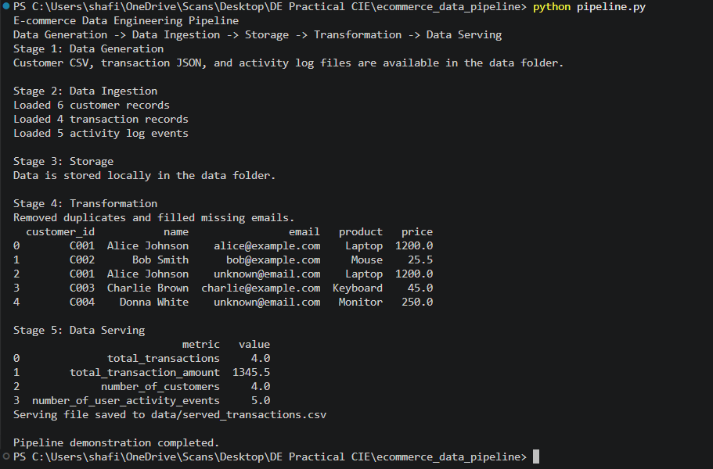

Analysis
Historical Transaction Processing:
Batch ingestion is more suitable because historical records can be collected and processed together efficiently.
Real-Time User Activity Monitoring:
Streaming ingestion is more suitable because events can be processed continuously with lower latency.

CONCLUSION:
The practical successfully demonstrates the basic data engineering lifecycle:
Data Generation → Data Ingestion → Storage → Transformation → Data Serving
CSV, JSON, and log files were used as different data sources. Basic profiling identified missing values, duplicate records, and inconsistent formats. Batch ingestion was used for historical data, while streaming-style ingestion was used for continuous user activity.
Therefore, batch ingestion is suitable for historical transaction processing, while streaming ingestion is suitable for real-time user activity monitoring.

GITHUB REPOSITORY LINK:

